

Introduction to Amazon EC2

AWS Lab 3

Evan Choi | Cisco CCNP | 4/24/2022

**Background Information**

Amazon Elastic Compute Cloud (EC2) is a web service that provides scalable computing capacity in AWS Cloud. You can obtain and configure capacity easily with EC2’s web service. It lets you have complete control of your computer resources. It also reduces the time needed to obtain and boot new server instances, which lets you scale capacity in a very fast time. It is also very good economically because you only pay for the capacity that you use.

**Configuration Steps**

Accessing the AWS Management Console

1. Click the start lab button until you get the **“Lab status ready”** message



1. Open the AWS Management Console by clicking the AWS button



Launching Your EC2 Instance

1. Click the **Services** box, then click **All Services,** and click on **EC2**

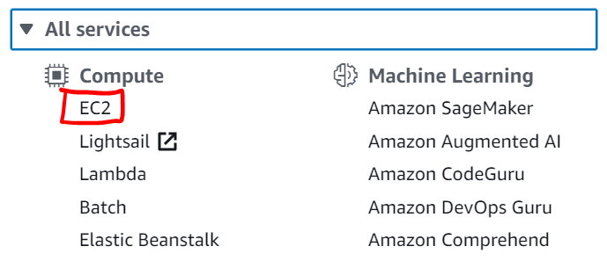

1. Make sure the region at the top says **N. Virginia**



1. Click the orange **Launch instance** button, then select **Launch Instance**

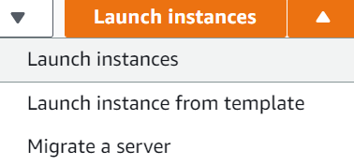

Choose an Amazon Machine Image (AMI)

1. In the Name and tags section, configure **Key:** Name and **Value:** Web Server. This will add tags

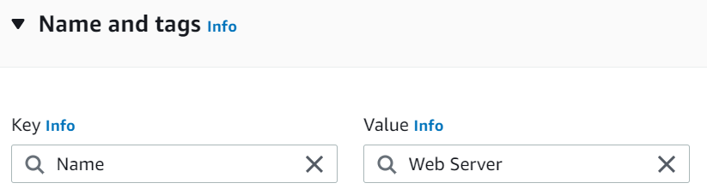

1. Next, in the AMI section, under Quick Start, select **Amazon Linux 2 AMI (HVM)**

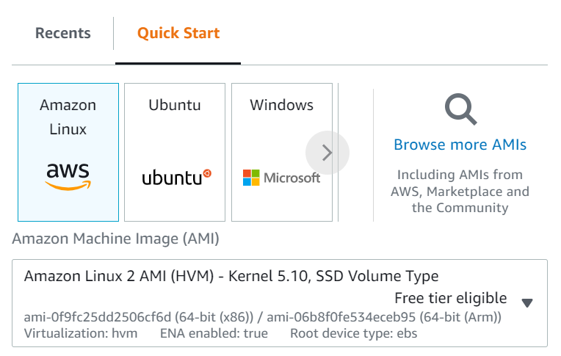

1. Now, in the Instance Type section, keep it the default instance, which should be **t2.micro**

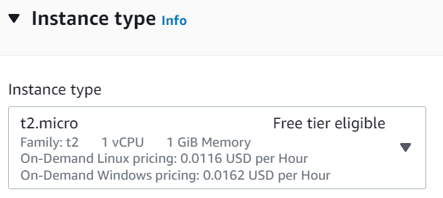

1. Under the Network settings section, for **Network,** select **Lab VPC**

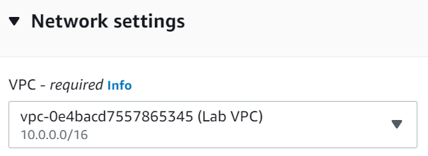

1. Under Security group name, configure: **Security group name:** Web Server security group and **Description:** Security group for my web server

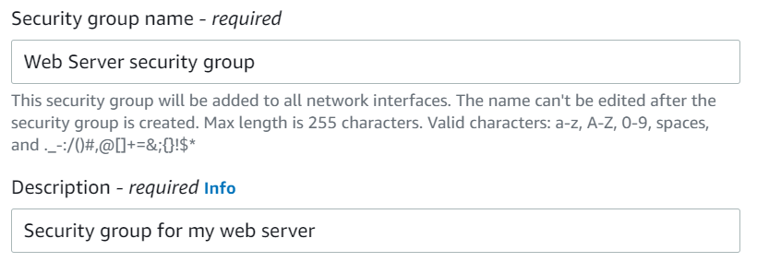

1. Under the Inbound security groups rules area, remove the **SSH** rule

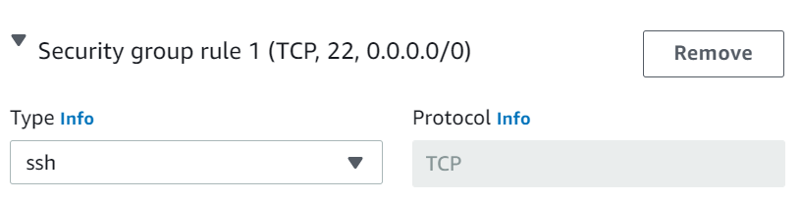

1. In the Advanced Details section, under the Termination protection area, select **Enable**
2. Finally, in User data, paste the following:

#!/bin/bash

yum -y install httpd

systemctl enable httpd

systemctl start httpd

echo '<html><h1>Hello From Your Web Server!</h1></html>' > /var/www/html/index.html

This installs an Apache web server, configures the web server to start automatically when it boots, and activates the Web server

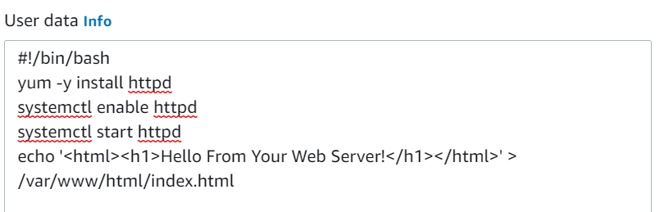

1. Scroll to the very bottom and click the orange **Launch Instances** button
2. A window saying **Select an existing key pair or create a new key pair** should appear
3. Click the **Choose an existing key pair** drop-down and click **Proceed without a key pair**
4. Click **Launch Instance**
5. Click the orange **View all Instances** button



1. Your **Web Server** should be selected. If not, select scroll to the right until you see the **Security Group Name** column. Select the one that says **Web Server security group**

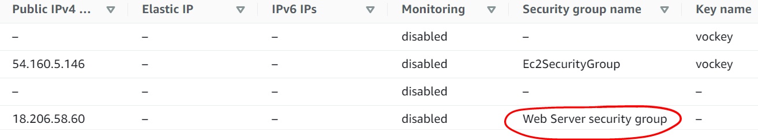

1. Wait until under the **Instance State** column it says: running and under the **Status Checks** column it says 2/2 checks passed



Monitor Your Instance

1. Check the **Status Checks** tab and make sure that the **System reachability** and **Instance reachability** checks have passed



1. At the top, in the **Actions** menu, select **Monitor and troubleshoot**, then click **Get system log**

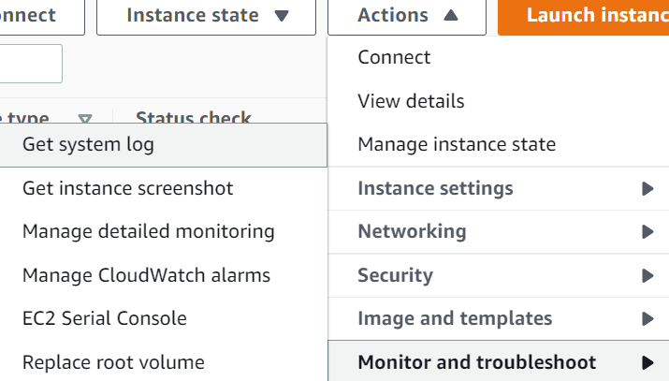

1. From this, you can see that the HTTP package was installed from the **user data**

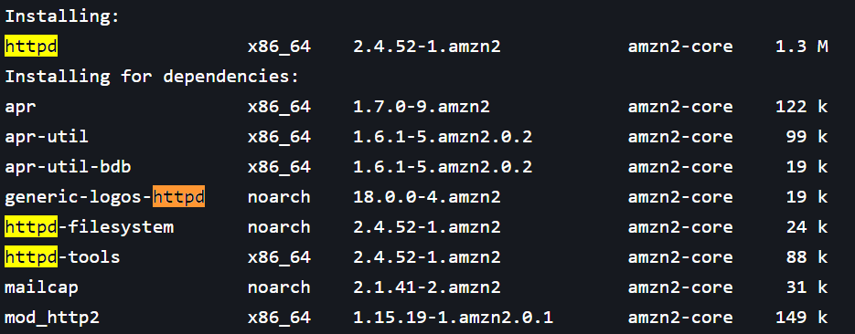

1. Click the **Cancel** button
2. At the top, in the **Actions** menu, select **Monitor and troubleshoot**, then click **Get instance screenshot**

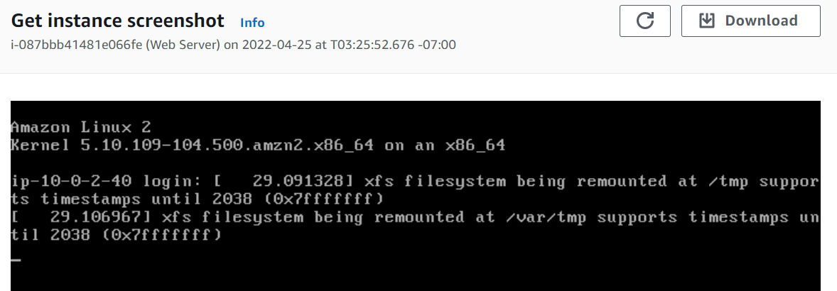

If your EC2 instance console had a screen, this is what it would look like

1. Click the **Cancel** button

Updating Your Security Group and Accessing the Web Server

1. If you go on the **Details** tab and copy the **IPv4 Public IP** and paste it into a web browser, you won’t be able to access it since your security group is not allowing inbound traffic on port 80, the port that allows HTTP web requests.
2. To fix this, go to the **EC2 Management Console** tab
3. On the left menu, scroll down till you find **Security Groups.** Click on it

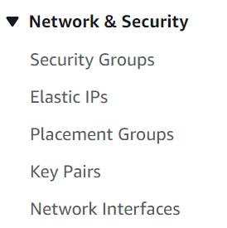

1. Select **Web Server security group**

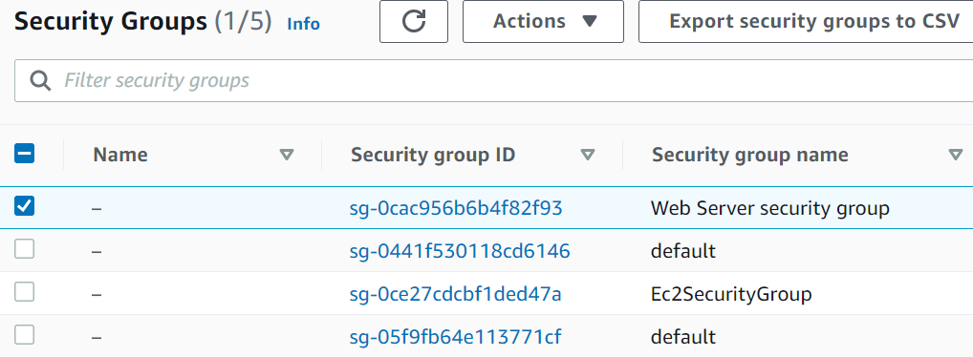

1. Click the **Inbound rules** tab and then **Edit inbound rules** and configure the following then click the **Save rules** button

**Type:** HTTP

**Source:** Anywhere-IPv4

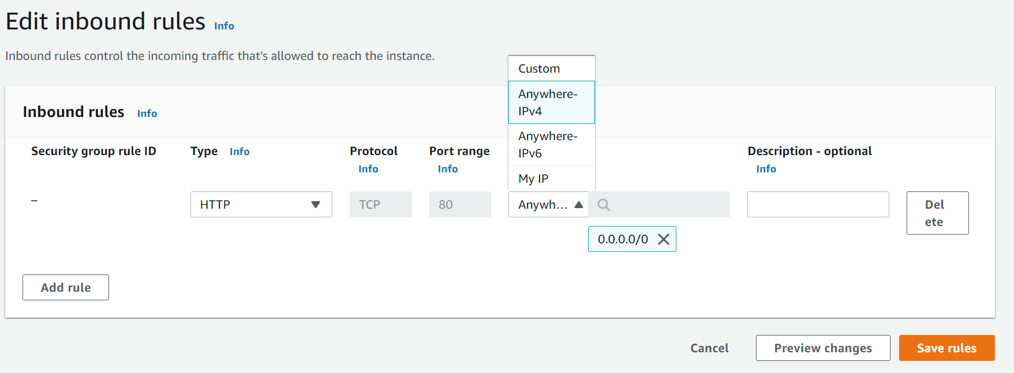

1. Open the web server tab from before. You should get a message saying **Hello From Your Web Server!**

Resizing Your Instance: Instance Type and EBS Volume

1. On the left menu, click **Instances.** Click the Instance State menu dropdown, and select **Stop instance**

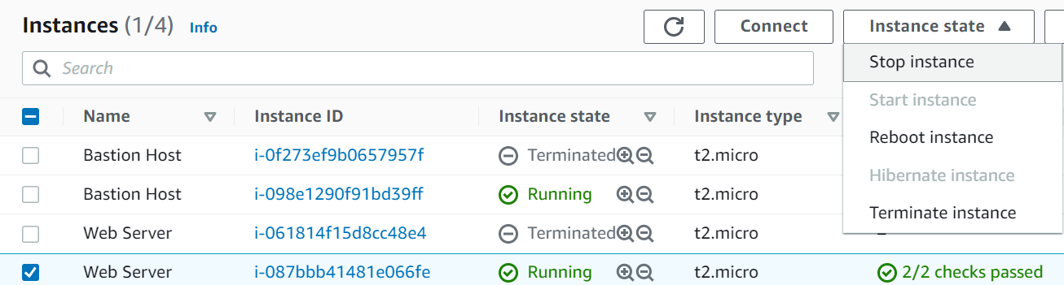

Changing The Instance Type

1. In the Actions drop-down click **Instance Settings,** then click **Change Instance Type**

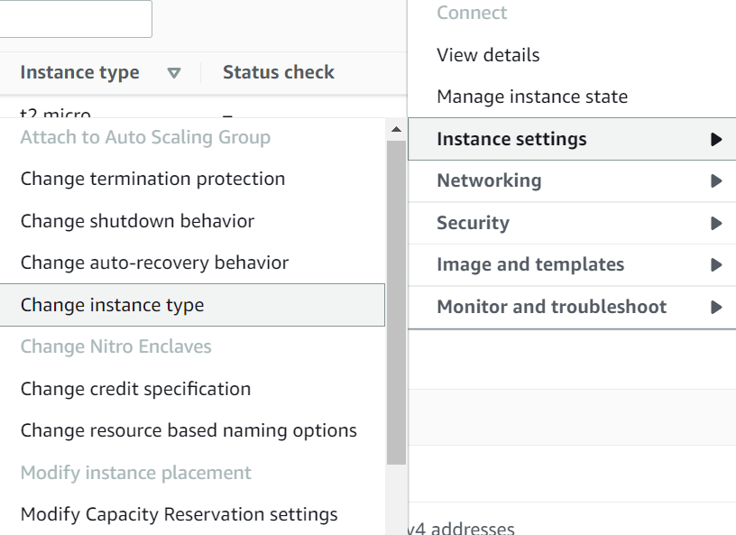

1. Change the Instance type to **t2.small** and click the orange **apply** button

Resizing the EBS Volume

1. On the left menu select **Volumes**

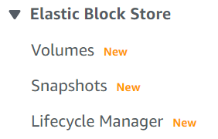

1. Click the **Actions** drop-down and select **Modify Volume**
2. Change the size to **10.** Click **Modify.** Click **Modify** again. Click the **Close** button

Starting the Resized Instance

1. On the left menu, click **Instances.** Then, on the Instance State drop-down click **Start instance**

Exploring EC2 Limits

1. On the left menu, select **Limits**
2. On the **All Limits** drop-down select **Running instances**

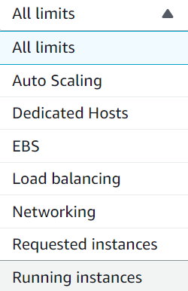

Testing Termination Protection

1. On the left menu, select **Instances**
2. Click the **Instances state** drop-down and select **Terminate instance.** Click the orange **Terminate** button

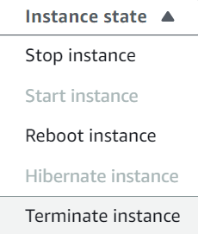

1. You should get this message, showing that termination protection is enabled.



1. Click the **Actions** drop-down, then click **Instance settings**, then click **Change termination protection**
2. Remove the check mark next to **Enable.** Click **Save**
3. Go back to the **Instances state** drop-down and select **Terminate instance.** Click the orange **Terminate** button.
4. The instance should be terminated

You have finished this lab!

1. Click the **End Lab** button and select the blue **Yes** button.



**Conclusion**

In this lab, you will monitor your EC2 instance, launch a web server with termination protection, allow HTTP access by modifying the security group your web server is using, resize your EC2 instance, explore the limits of EC2, test the termination protection of your web server, and terminate your EC2 instance.